**Rotational Inertia**

**Pre-lab questions**

1. What is the goal of this experiment? What physics and general science concepts does this activity demonstrate to the student?
2. How is angular acceleration related to torque?
3. Suppose a ring and a disk have equal mass, *M*, and equal outer radius, *R*. Which one should have a bigger moment of inertia?

The goal of this experiment is to investigate the concept of inertia in rotational motion. In what ways is it similar to the linear inertia concept of mass, and how is it different?

**Introduction**

Inertia in linear (straight-line) motion describes the difficulty in changing an object’s state of motion in response to an applied force. Newton’s 2nd law, $F= {∆p}/{∆t}=ma$, gives the concept a mathematical form and serves as an operational definition of linear inertia, or **mass**, when that inertia is constant.

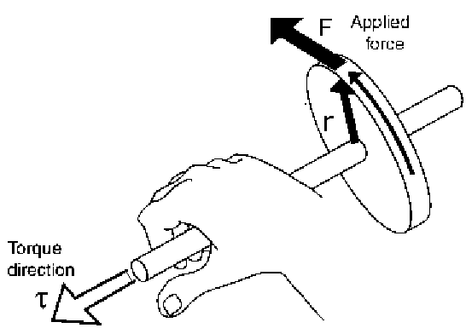Rotational motion, and **rotational inertia**, can be considered analogously. Now **torque**, which is derived from application of a force **F** through a moment arm **r** (about a rotation axis) as the vector cross product $τ=r×F$, serves in a similar way to define rotational inertia.

Figure 1: The torque of force **F** acting through moment arm **r**.

We saw that Newton’s 2nd law relates force to changing momentum and acceleration through mass. The rotational analogue, $τ={∆L}/{∆t}=Iα$, relates torque to the time rate of change of angular momentum, $L=r×p=Iω$, and angular acceleration **α** through the rotational inertia *I*. The rotational inertia (or moment of inertia) for a single mass *m* in turn depends on the distance *r* that the mass is positioned from the axis of rotation, as *I* = *mr*2. (To see this simply, just think about why a doorknob is always positioned at the opposite end of a door from its hinges.) For an extended, massive object, the rotational inertia is more complicated to calculate theoretically.

**Equipment:**

Rotary motion sensor and rotational accessory, pulley, slotted masses and hanger, rod and table clamp, vernier caliper, balance scale.

**Experiment**

The rotational inertia of an object is a measure of how hard it is to rotate the object. The purpose of this experiment is to find the rotational inertia of a ring and a disk experimentally, and to compare these values correspond to the calculated theoretical values.

A known torque is applied to the three-step pulley on the Rotary Motion Sensor, causing a disk and ring to rotate. The resulting angular acceleration is measured using the slope of a graph of angular velocity versus time. The rotational inertia of the disk and ring combination is calculated from the torque and the angular acceleration. The procedure is repeated for the disk alone to find the rotational inertias of the ring and disk separately.

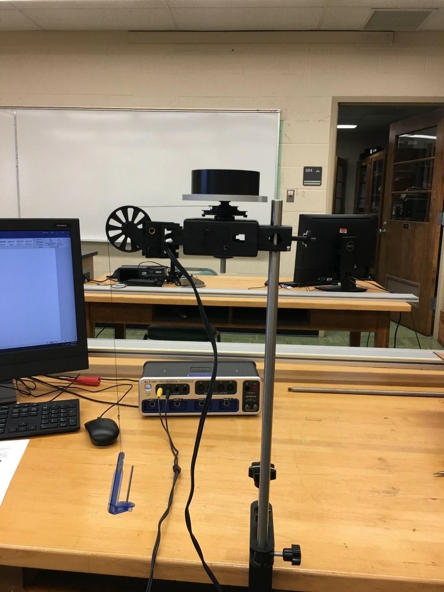

Figure 2: Measuring the Rotational Inertia of Ring and Disk

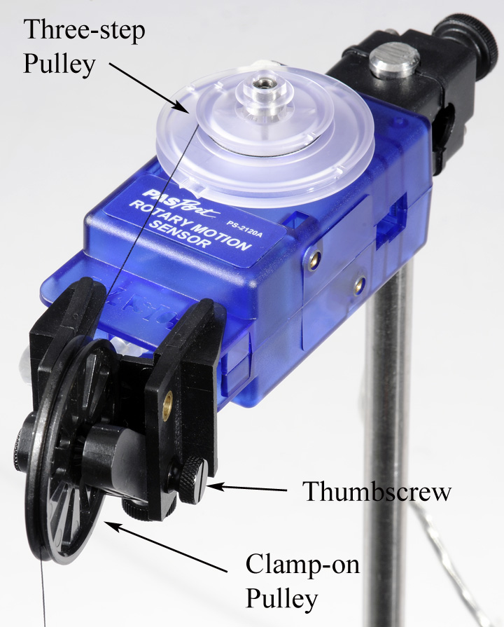

Figure 3: Attaching Thread to Pulley

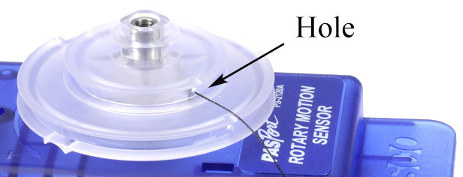

Figure 4: Adjusting Angle of Clamp-on Pulley

**Setup**

1. Use the table clamp and the 45 cm rod to support the Rotary Motion Sensor as shown in Figure 2. Plug the sensor into the interface. (Some may plug into a PASPORT jack)
2. Use calipers to measure the radius (*r*) of the medium size pulley on the clear three-step pulley, or if tie off at hole on top of middle pulley if using that type.
3. Cut a piece of thread about 75 cm long. Run the thread through the hole in the medium size pulley as shown in Figure 3. Tie a large knot inside the pulley to keep the thread from pulling though.
4. Clamp the black pulley onto the Rotary Motion Sensor as shown in Figure 4. Note how the pulley is clamped at an angle to match the tangent to the clear three-step pulley. It must also be adjusted vertically using the two thumbscrews, to match the height of the clear pulley being used.
5. Connect a mass hanger to the end of the thread. Adjust the length so that it doesn't quite hit the floor.
6. When you wind up the thread onto the three-step pulley, make sure the thread winds smoothly with no overlaps. Make sure you always wind onto the middle pulley. Also, do not place too much thread on the pulley: You only want a single layer of thread, so that the radius stays constant.
7. In PASCO Capstone, create a graph of Angular Velocity vs. Time. Set the sample rate to 20 Hz.
8. Create a table (shown below) in which all the columns are User-Entered Data sets.

|  |  |  |  |
| --- | --- | --- | --- |
| Combined | Hanging Mass  (g) | Ang. Acceleration  (rad/s2) | Friction Mass  (g) |
| Ring & Disk | **50.0** | **10.8** | **0.9** |
| Disk & Pulley | **15.0** | **14.1** | **0.7** |
| Pulley | **1.3** | **24.0** | **0.0** |

**Setup Theory**

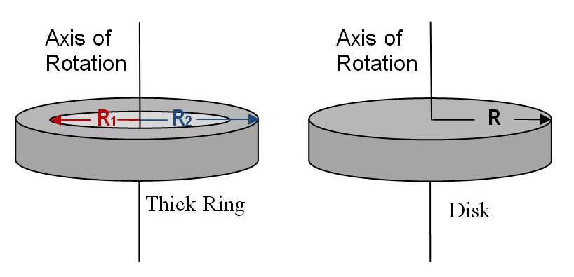

Figure 5: Rotation Axis for Ring and Disk

Theoretically, the rotational inertia, *I*, of a thick ring about an axis passing through the center is given by

*I* = ½*M*(*R*₁2 + *R*22)   (1)

where *M* is the mass of the ring, *R*1 is the inner radius of the ring, and *R*2 is the outer radius of the ring, as shown in Figure 5. The rotational inertia of a disk is given by

*I* = ½*MR*² (2)

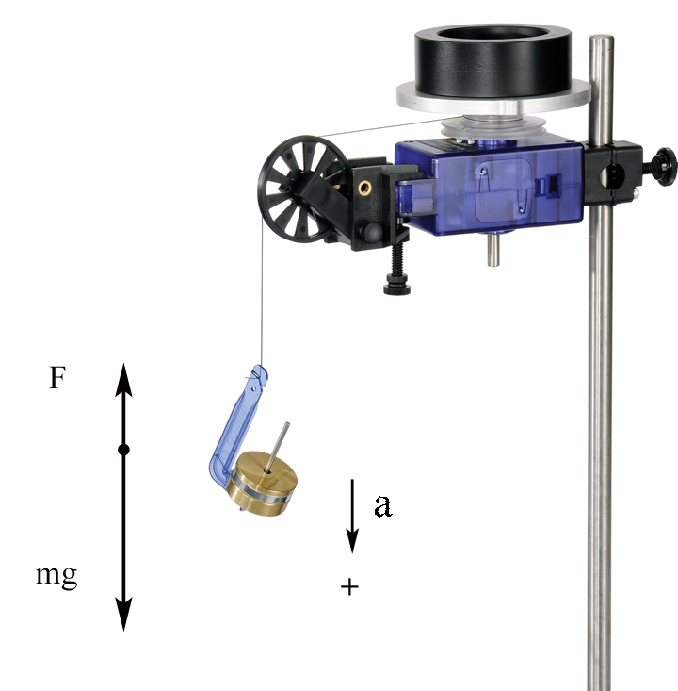

Figure 6: Free-Body Diagram

where *M* is the mass of the disk and *R* is the radius of the disk.

To find the rotational inertia of the ring and disk experimentally, a known torque is applied to the ring and disk, and the resulting angular acceleration, *α*, is measured.

*τ* = *Iα* (3)

where *τ* is the torque caused by the weight hanging from the thread wrapped around the pulley of radius, *r*.

*τ* = *r F* (4)

The tension in the string, *F*, is less than the weight, due to the downward acceleration. Applying Newton's Second Law for the hanging mass, *m*, (see Figure 6) yields

*F* = *m*(*g* - *a*) (5)

Finally, the linear acceleration, *a*, is related to the angular acceleration, *α*, by

*a* = *r α* (6)

**Procedure**

1. Fasten the disk to the shaft of the Rotary Motion Sensor using the thumbscrew. Position the ring on top using the two pins to key it to the disk.
2. Hang about 50 g on the mass hanger, and collect a run of angular velocity vs. time data. Record all values in table above.
3. Highlight the falling section of data  and then use a linear curve fit to find the angular acceleration. 
4. Accounting for Friction: Put just enough mass on the thread to make it fall at a constant speed after you give it a starting push. It will only be about a gram so you won't be able to use the mass hanger! This is called the friction mass, and is subtracted from the hanging mass in the calculations on the next page.
5. Remove the ring, and repeat the above procedure for just the disk. Use about 15g, and find the friction mass, too.
6. Remove the disk and repeat for just the pulley. Use about 1 g, but don't bother with the friction mass: It is too small.

**Analysis**

1. Measure and record these apparatus values:

|  |  |
| --- | --- |
| Radius of the middle pulley | **0.01435 m** |
| Radius of the disk | **0.0475 m** |
| Mass of the disk | **0.1121 kg** |
| Outer radius of the ring | **0.038 m** |
| Inner radius of the ring | **0.02705 m** |
| Mass of the ring | **0.4564 kg** |

1. Use the angular acceleration you measured for the ring & disk to calculate their combined rotational inertia. You will first need to calculate the applied torque using Equations (4) through (6). Remember to subtract the friction mass from your value for the hanging mass before doing the calculation.

|  |  |  |  |
| --- | --- | --- | --- |
| **Object** | **Experimental Rotational Inertia** | **Theoretical Rotational Inertia** | **Percent error** |
| Ring |  |  |  |
| Disk |  |  |  |

1. Use Equation (3) to calculate the rotational inertia of the ring & disk combined.
2. Repeat steps 1 and 2 above to calculate the rotational inertia for the Disk & Pulley.
3. Repeat steps 1 and 2 above to calculate the rotational inertia for the Pulley.
4. Subtract the (Disk & Pulley) inertia from the (Ring & Disk) inertia to calculate the rotational inertia of just the ring.
5. Subtract the (Pulley) inertia from the (Disk & Pulley) inertia to calculate the rotational inertia of just the disk.
6. Use Equations (1) and (2) to calculate the theoretical rotational inertias for the ring and disk. Compare to the measured inertia using a % error calculation.